Install git  
install docker

Run docker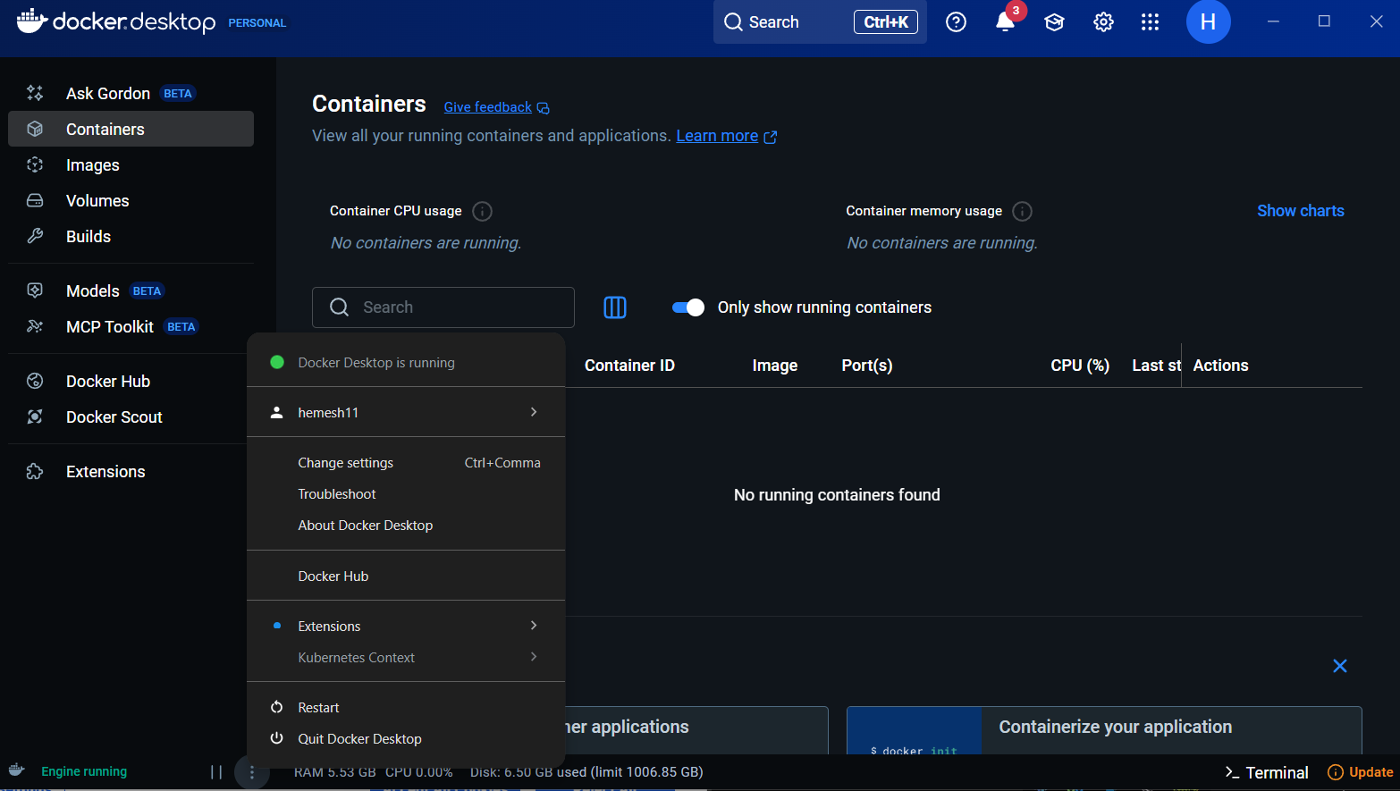

Go to github repo of cvat and clone it

Run this command to start cvat docker container

When you run cvat server for first time we need to create superuser account and signup:

Enter username, mail and password

Go to <https://localhost:8080>

Enter your credentials and sigin to use cvat in offline mode:

Create new task, upload dataset and annotate them (bounding box, polygon):

After finishing, save and export in yolo 1.1 (bounding box) or yolo – seg (polygon) format:

After finishing, close cvat, stop docker from command prompt:

